**PROJECT ON WIND ENERGY GENERATION**

**ABSTRACT:**

In this project we have developed low cost wind energy to electricity conversion device. We made it with locally available components. A dynamo is directly coupled to a fan blade to generate electricity. Wind power is the conversion of wind energy into a useful form of energy, such as using wind turbines to make electricity, windmills for mechanical power, wind pumps for water pumping or drainage, or sails to propel ships.

Large-scale wind farms are connected to the electric power transmission network; smaller facilities are used to provide electricity to isolated locations. Utility companies increasingly buy back surplus electricity produced by small domestic turbines. Wind energy, as an alternative to fossil fuels, is plentiful, renewable, widely distributed, clean, and produces no greenhouse gas emissions during operation. The construction of wind farms is not universally welcomed because of their visual impact, but any effects on the environment from wind power are generally less problematic than those of any other power source.

Operating principle: An electric coil cutting the permanent magnet magnetic field produces electricity as explained by Fleming’s law. Depending on the direction of the rotation of the blade DC voltage ranging from 1 volt to 12v is generated.

Parts used: we used mini dynamo with gear arrangement for direct coupling with the fan blade. Two sets of probes are used to detect presence of water. A transformer is used to step down the ac to dc 12V for the operation of the circuit.

**Block Diagram:**

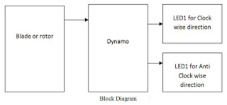

**Applications:**

1) Emergency Light

2) Cell phone charging

3)Village street lighting system

